# Questions :

* Why is "matrixtask" using most of the CPU utilization?

Because of :-

1. The matrix multiplication involves a large number of floating-point operations, and it is known to be a computationally intensive task.
2. Without explicit calls to “vTaskDelay()” or other mechanisms that yield the processor to other tasks, the task may monopolize the CPU, preventing other tasks from running.

* Why must the priority of "communicationtask" increase in order for it to work properly ?

Because with higher priority other tasks won’t preempt it and it will preempt any other task when it’s ready to work .

* What happens to the completion time of "matrixtask" when the priority of "communicationtask" is increased?

The completion time may increase as it may preempted by “communicationtask” and it won’t be capable to finish while “communicationtask” still in need to the cpu .

* How many seconds is the period of "matrixtask"?

The period appears to be about 1ms

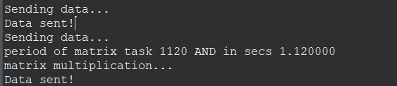

# Screenshots

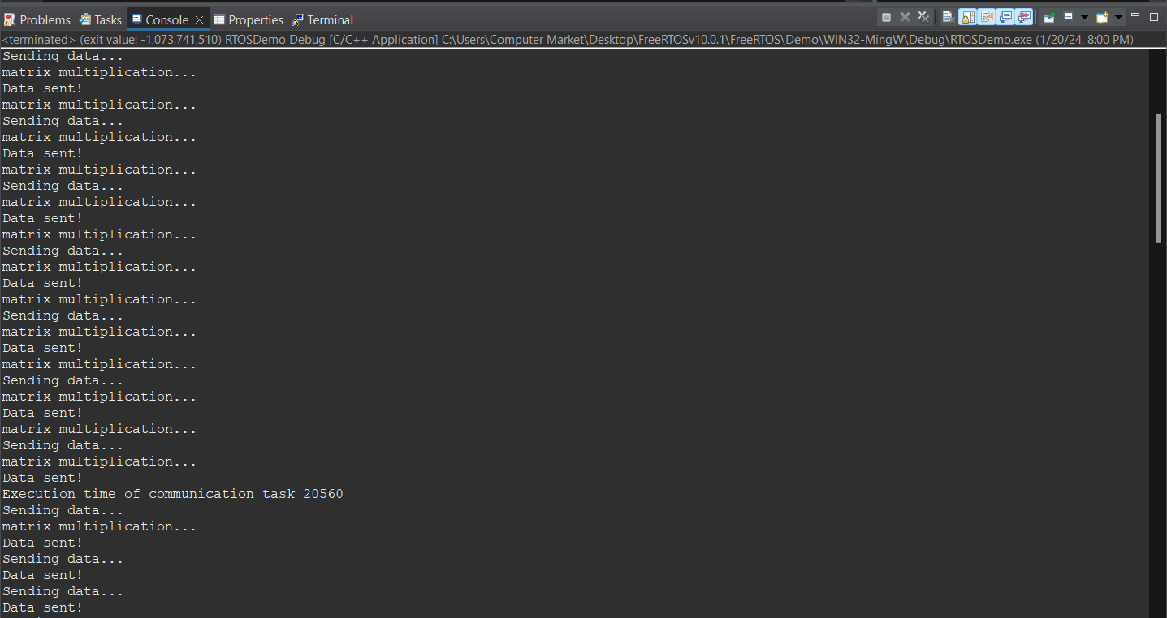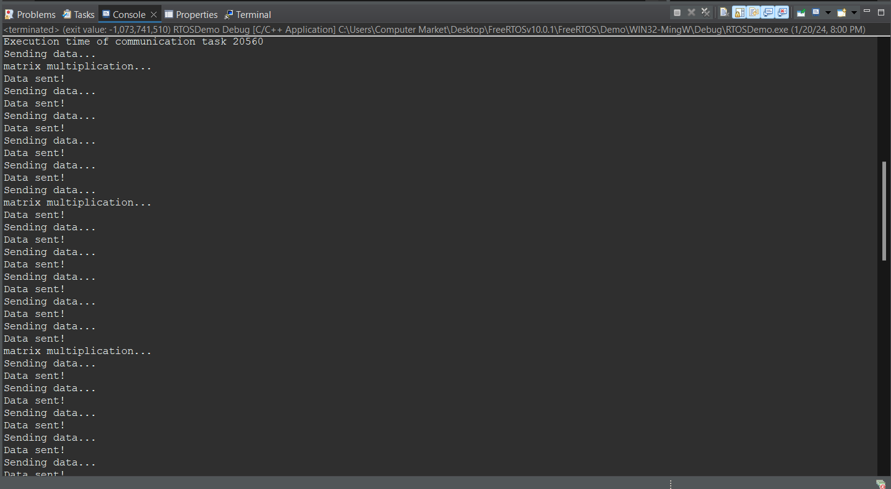

After the priority of the Communication changes

Before the priority of the Communication changes